Post Arcana / NPCs

Architecture/Design Document

**Table of Contents**

1. Introduction

2. Design Goals

3. System Architecture

4. Mid Level Design

5. Detailed Class Design

6. Process View

7. Use Case View

**Change History**

**Version:** 0.1

**Modifier:** Colin Brandow

**Date:** 03/12/2022

**Changes:** Design Document Created

**Version:** 0.2

**Modifier:** Colin Brandow

**Date:** 04/08/2022

**Changes:** System Architecture and Detailed Class Design

**Version:** 0.3

**Modifier:** Colin Brandow

**Date:** 04/09/2022

**Changes:** Document completed

1. Introduction

This document describes the design and architecture of Post Arcana by the Hex Decimals. Post Arcana is a single player open world RPG, set in a post apocalyptic small Canadian town after the introduction of magic to the real world.

The purpose of this document is to define the architecture and design of the NPC systemin a manner that assists the interests of all major stakeholders. The major stakeholders and their interests are as follows:

* Developers: A design that is easy to implement that minimizes complexity
* Project Manager: A design that can be easily divided among the skills of the programmers
* Maintenance Programmers: A design that can be improved upon easily

1. Design Goals

The design goals for the NPC system are as follows:

* The design must minimize complexity
* The design must allow for multiple NPC behaviors and dialogues that are easy to implement
* The design should be easy to amend and balance

1. System Architecture

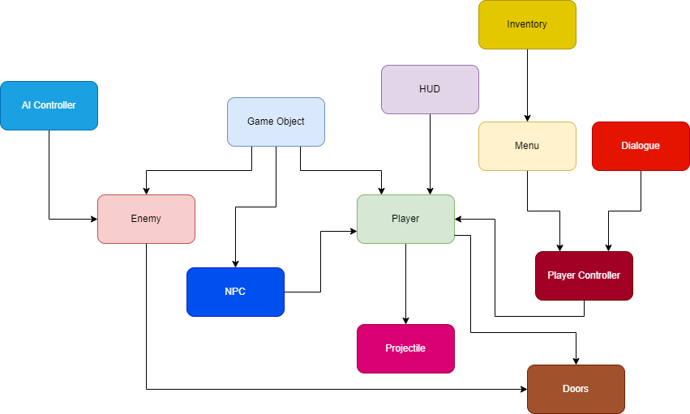

* GameObject: Base class for the game entities (Players and enemies). Stores abstract and concrete stats.
* Enemy: The class used for enemy-only stats and components
* AI Controller: Moves and controls the enemies
* Player: The class used for player-only stats and components
* Player Controller: Receives player input and controls the player
* Projectile: Is launchd by the player, and deals damage to Game Objects
* Menu: Places a UI element on the screen given a specific input
* HUD: Shows the player important stats
* Dialogue: Shows the player NPC dialogue
* NPC: The class used to allow NPCs to talk and modify the player
* Doors: Runs the interactable doors
* Inventory: Allows for the player to have an inventory

1. Mid Level Design

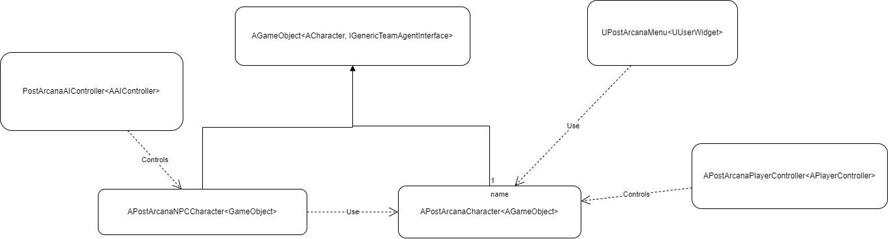

1. Detailed Class Design

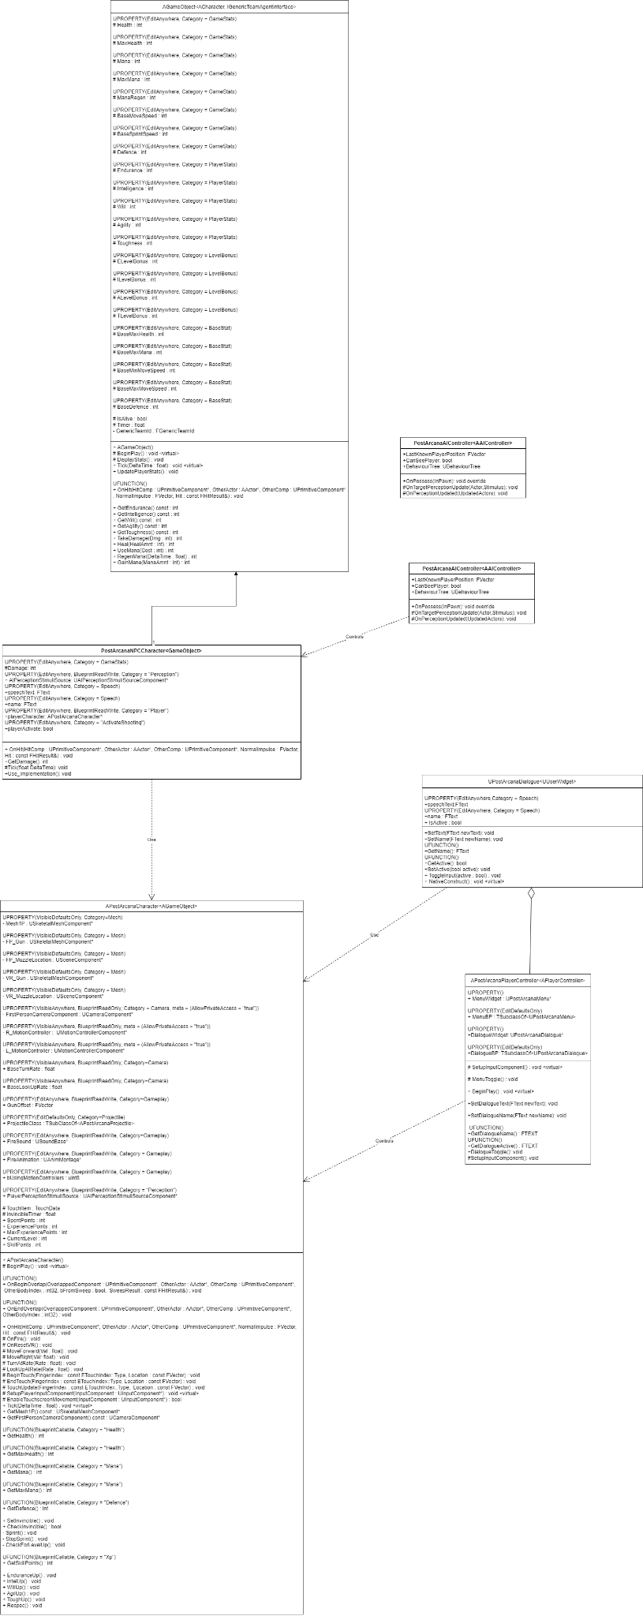

1. Process View

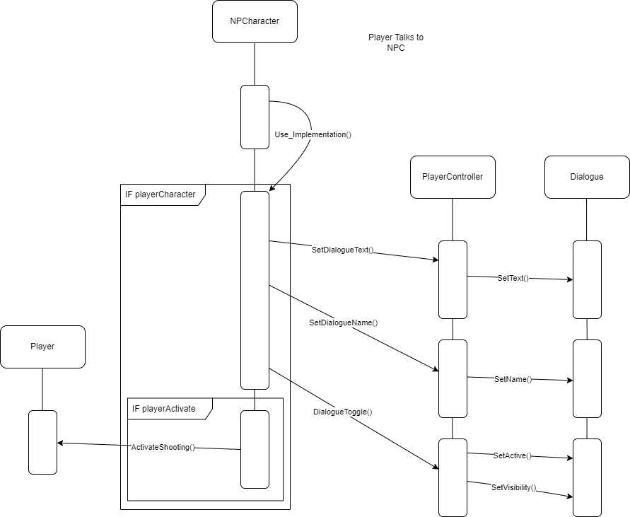

When the player implements use on an NPC it will first call Use_Implementation on the NPC. The NPC will then check if they have a pointer to the player. If they do, they will get that player’s controller and call SetDialogueText, SetDialogueName and Dialogue Toggle on it. The controller will then call SetText, SetName, SetActive and Set Visibility on its Dialogue Widget, pulling up the dialogue menu with the correct text and associated name. Then if the NPC is set to activate the player’s shooting it will call activate shooting on the player.

1. Use Case View

When setting up an NPC multiple steps must be taken. First you’ll want to drag the NPC blueprint onto the scene in your preferred location, as seen below:

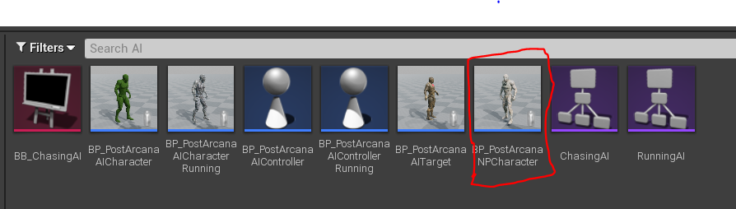

Next you MUST give the NPC a unique name. If you use the same name for multiple NPCs it will be impossible to talk to any of them. You will also want to set the dialogue text such that it doesn’t display the test dialogue. The name and dialogue can be set under the Speech heading as seen below:

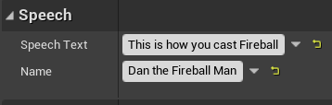

Next, you must set the Player to the active first person player on the level you wish to place the NPC. This is to give the NPC a pointer to the player, and more importantly the player’s dialogue window. This can be found under the player heading as seen below:

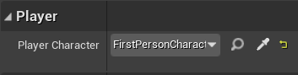

If you wish to set a behavior for the AI, that can be done under the pawn heading as seen below:

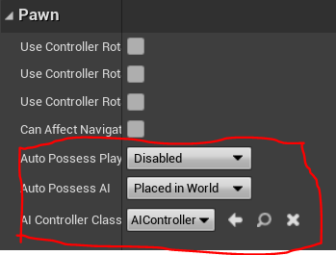

The NPC also has stats which can be modified under the Base Stats, Player Stats, and Level Bonus tabs:

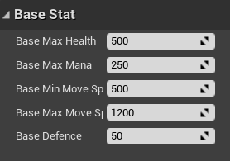

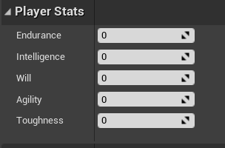

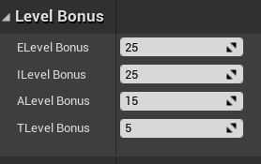

Finally if you want this NPC to activate the player’s shooting you must check the Player Activate box under Activate Shooting:

